GO TO

<https://www.eclipse.org/downloads/>

CLICK DOWLOAD

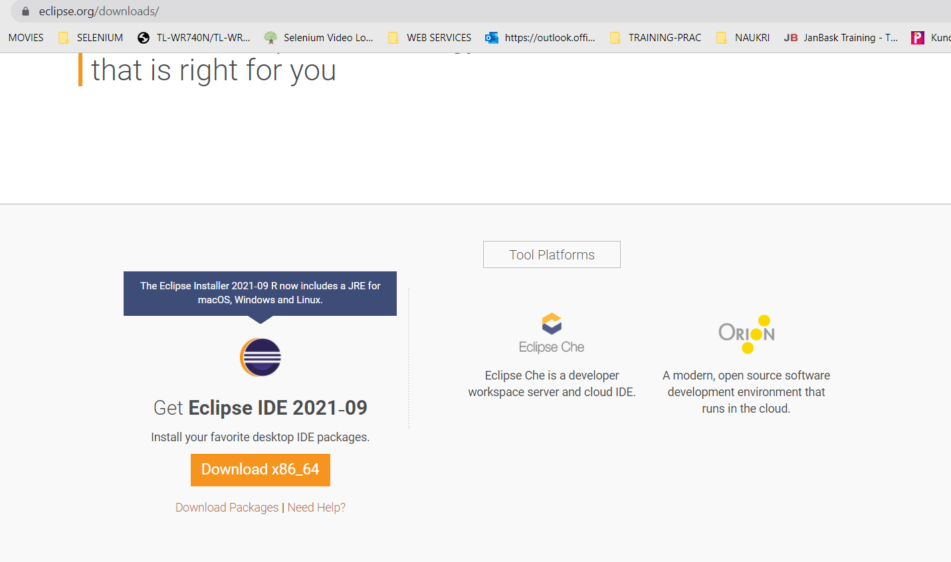

CLICK DOWNLOAD

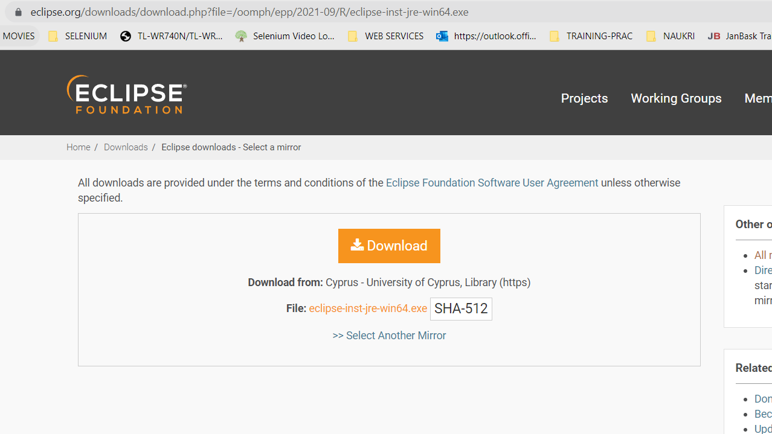

CHOOSE ECLIPSE IDE FOR JAVA DEVELOPERS

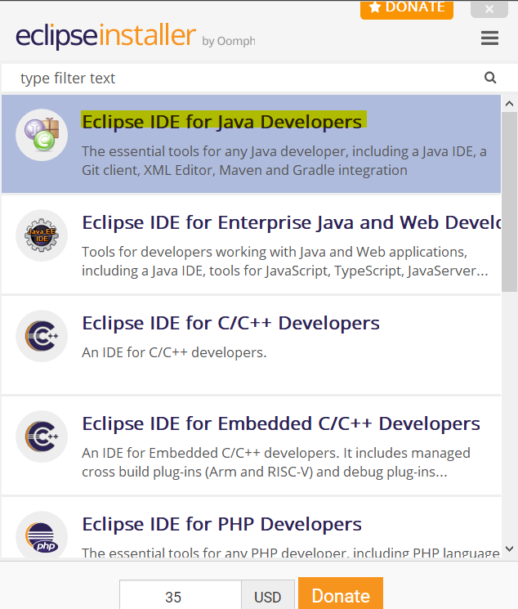

CHOOSE WORSPACE

CLICK HIDE ON TOP RIGHT CORNER

